Chapter 3 p.70

Countries most targeted by North Korean state-sponsored threat actors

Unsurprisingly, the US and South Korea comprise over 50 percent of North Korea’s cyber focus.

Bar graph showing Countries most targeted by North Korean state-sponsored threat actors. X-axis represents countries namely the United States, South Korea, Japan, United Kingdom, Australia, Switzerland, Denmark, Italy, B, Other and y-axis represents percentages from 0 to 50% in intervals of 10%. Highest percentages are seen in the United States with approx. 40%, followed by South Korea with approx. 15%, and negligible percentages are seen in countries Belgium, France, Germany, South Africa, Sweden, and Türkiye.

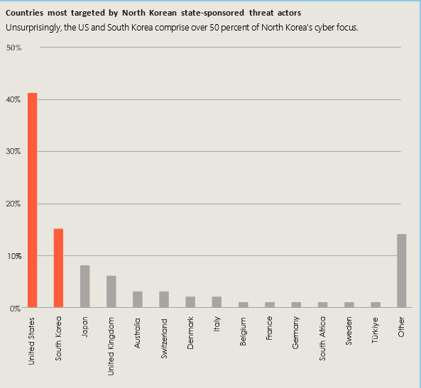

Source: Microsoft Threat Intelligence events data